A6-How to set Universal Repeater Mode
Product line: Wireless Question category: Function Configurations

Q: Why we need to set A6 works as Universal Repeater Mode?
A: Sometimes we want to extend the coverage of the wireless network, and keep the wireless devices getting online wirelessly and be in the same LAN range for easy management, Universal Repeater Mode can realize it.

The topology should be as below:
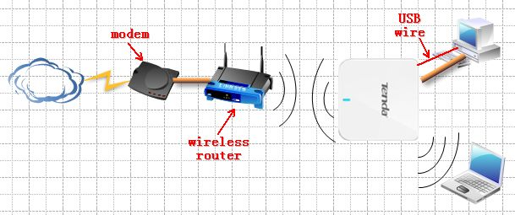

The steps are as below:
1. Make sure that you can access to the internet when you just connect your computer to uplink wireless router.
2. Login to the homepage of A6.
3. Click Quick Setup->Universal Repeater Mode and click Next
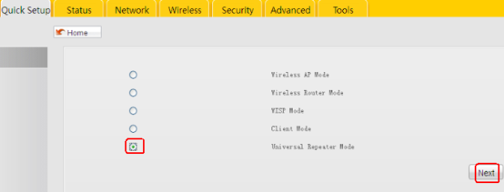
4. Click Scan, then find and choose your uplink router’s SSID and input its security key and click Next.
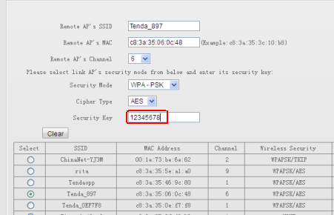

5. In the following page, you can change the SSID(the name of your WiFi, please select the same Security Mode and Cipher Type as your uplink router, then set an at least 8 character’s Security Key for your WiFi.
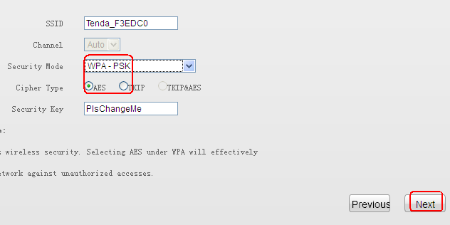
6. Click Finish to save the settings.
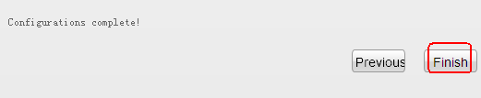

7. Connect your devices to the A6 by wire or wireless, and then change your computer to obtain an IP address automatically, if your computer can get an IP address from your uplink router, then you can get online.

